Founder & Artistic Director

Welly Yang

General Manager

Grace C. Lee

Senior Artists
David Henry Hwang
Woody Pak
Brian Yorkey

Production Manager
Peter Chin

Development Coordinator
Arlene Yang

Board of Directors
Sherman Chin, Chairman
Yau Cheng, Secretary
Lloyd Cheu, Vice Chairman
Chad Tanaka, Treasurer
June Jee
Welly Yang

Board of Advisors

Danielle Chang

Cindy Hsu

Aldon James
Joseph Park

Jeff Yang

FOR IMMEDIATE RELEASE
Second Generation Presents the Third Annual Concert of Excellence Celebrating Asian Americans in the Performing Arts
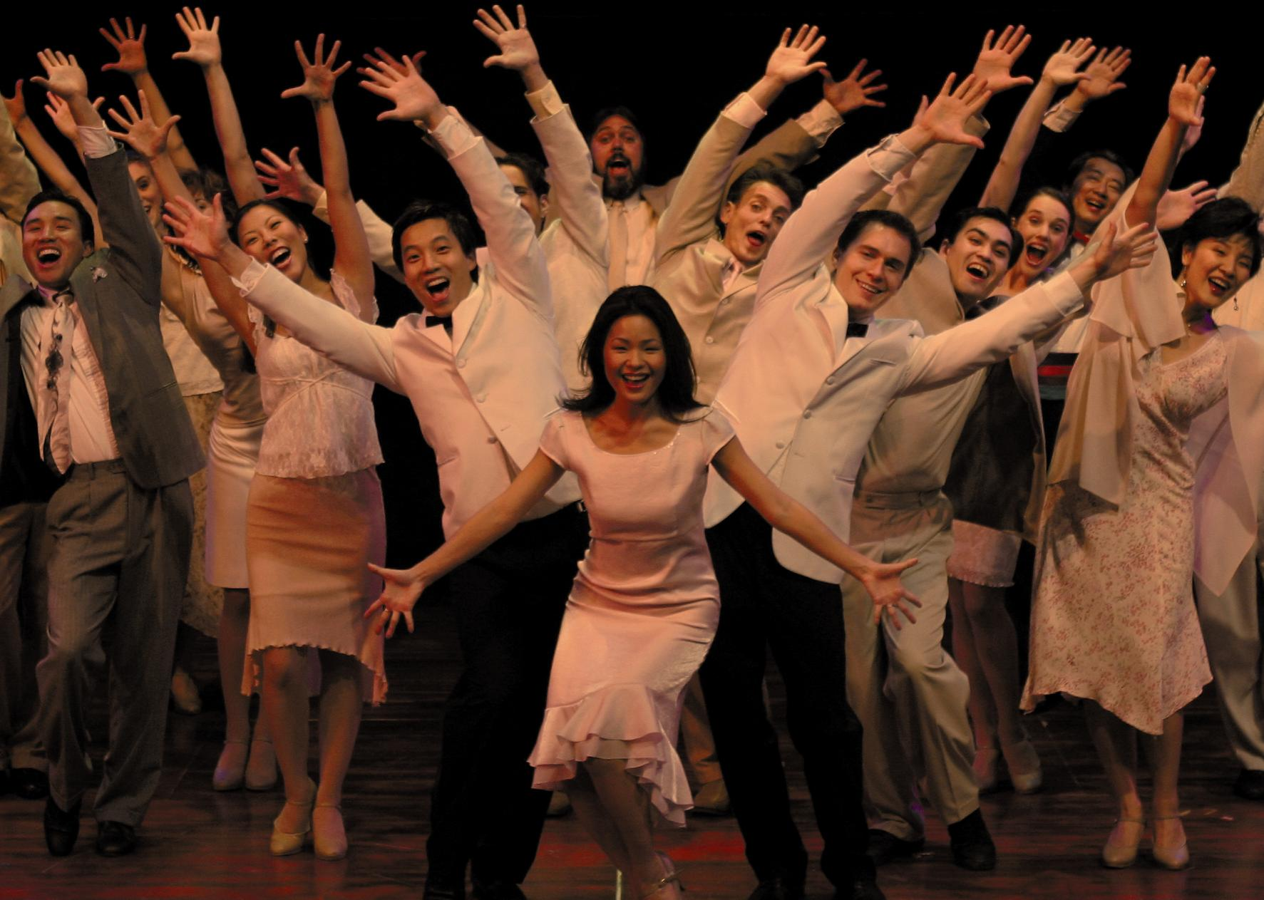
October 27th, 2003 - New York, NY- Second Generation is proud to present its Third Annual Concert of Excellence featuring the Rémy X.O Excellence Awards on Monday, December 1, 2003, 7:30 p.m., at Lincoln Center’s New York State Theater. Second Generation will be holding a press conference this Thursday, October 30th, with producing partners Rémy Martin and Chase Home Finance, to announce surprise guests and additional performers.
Attendees of the concert will revel in a star-studded and talent-filled evening that Tony Award and past Rémy X.O Excellence Award winner David Henry Hwang calls “the most professional, most fun, and most prestigious event of its kind for Asian and Asian American artists.” Luminaries from the worldwide Asian performing arts community will gather one night only for this celebration of song and dance that has been called “the Broadway Dream Team meets the Asian American Academy Awards.”
One of the highlights of the extravaganza is the presentation of the Rémy X.O Excellence Awards, honoring Asian Americans who have made pioneering contributions to the performing arts. This year’s honorees include Lou Diamond Phillips (Golden Globe-nominated actor for Stand and Deliver, La Bamba), B.D. Wong (Tony Award-winning actor, Law and Order: SVU, Oz), Bai Ling (star of the upcoming Star Wars Episode III), and Jadin Wong (legendary dancer and talent manager). Hollywood leading man Jason Scott Lee (Dragon: The Bruce Lee Story, Lilo & Stitch), a recipient of last year’s Award, will enliven the audience as master of ceremonies, along with a host of celebrity presenters including John Cho (American Wedding, Better Luck Tomorrow) and Randall Duk Kim (Matrix Reloaded & Matrix Revolutions).
Second Generation Artistic Director Welly Yang, Tony Award-winning musical director Jason Robert Brown (Parade, Urban Cowboy), and Lucille Lortel Award-winning director/choreographer Devanand Janki (Zanna Don’t!) have created an evening of top-notch entertainment. Jason Robert Brown is composing an original song for the Concert of Excellence’s opening number. An ensemble of 30 performers, including stars of such musicals as Flower Drum Song (Jose Llana, Emily Hsu), Nine (Rona Figueroa), Rent (Julie Danao), and Second Generation’s own musical The Wedding Banquet (Tyley Ross and Dina Morishita) will showcase the best of Broadway in over 14 numbers assembled just for the evening.
The select 60-voice Children’s Choir of Excellence will be led by All American Boys Chorus Director David Albulario and presented by Chase Home Finance. The Children’s Choir of Excellence will be featured performing 2 songs, including Stephen Sondheim’s “Our Time.”
With previous concerts having sold out Carnegie Hall and Lincoln Center’s Alice Tully Hall, this year’s Concert of Excellence at the New York State Theater promises to be the most spectacular to date.
Ticket prices are $50, $75, $100, and $250 VIP. Tickets are currently on sale at www.coe.2g.org, and available by phone through TheaterMania at (212) 352-3101.
For more Information about the Concert, Please Contact:
Angela C. Lee David Archer
Producer, The Concert of Excellence DA Associates
Phone: (212) 334-4777 (845) 424-4974
Email: mailto:angela@2g.org DAassociates@aol.com
Website: www.2g.org
The press conference will be hosted at one of the Concert of Excellence key sponsors, Holiday Inn Downtown. Welly Yang, star of The Wedding Banquet: The Musical, will be performing “This is True” a song from the musical that will be featured at this year’s Concert of Excellence.
Press Conference Details
Thursday, October 30, 2003
2:00pm
Holiday Inn Downtown
138 Lafayette St (off Howard St), Conference Room, 2nd floor
Cameras and photographers are welcome.
RSVP: Contact Blake at 212.925.5899 or blake@2g.org (RSVP required)
Second Generation is a New York based non-profit theater company dedicated to bringing Asian American stories to the world stage. The company commissions and produces full Broadway-scale musicals, such as The Wedding Banquet: The Musical and Making Tracks, and tours them nationally and internationally. In New York, the company produces and develops Off-Broadway plays, readings, concerts, and the upcoming off-Broadway hit, The Karaoke Show. The Concert of Excellence is sponsored by Rémy Martin, with major support from Chase Home Finance. Additional sponsors include Mohegan Sun, Con Edison, Lehman Brothers, Holiday Inn Downtown, Amerasia Bank, Loftworks Discount Designer Clothing Company, Harold L. Lee & Sons Insurance, Inc, World Journal, NY1 News, and Pro Motion. For more information on the Concert of Excellence, log onto www.2g,org.

